The Former Primitive Methodist Chapel, Queen Street, Mosborough.

By John Rotherham
May, 2025

The former Primitive Methodist Chapel at 36/38 Queen Street, Mosborough, was built in 1830 by the local community on land purchased for £19 10s from Job Allen (1772-1853), publican and maltster of the White Hart Inn, Eckington. Allen had acquired the land from the Crown Estate in 1828 when the Manor of Eckington was released for sale upon the open market.
The Primitive Methodist movement was founded in 1811 by Hugh Bourne and William Clowes in Staffordshire. They emphasized evangelism, outreach to the working class, and open-air preaching and quickly gained popularity among rural and industrial communities, such as Mosborough. The chapel was built before any of the present chapels in the Sheffield Circuit with the aid of a mortgage of £100 from Sheffield solicitor and land surveyor John Haywood of 19 Paradise Square, Sheffield.
The modest, stone-faced building (Figure 1) is simple and functional, distinguished by the keystone arch over the entrance, which reflects the movement’s emphasis on humility and accessibility. The accommodation rapidly became too small for its congregation and school, leading to efforts to raise funds for expansion. With the help of Sheffield cutlers, Messrs. Gilbert and Jones, the local community raised funds in 1868 to pay off the outstanding debt of £70 preparatory to building a new chapel alongside the existing one. Shortly afterwards, the Old Chapel was converted for use as two cottages.

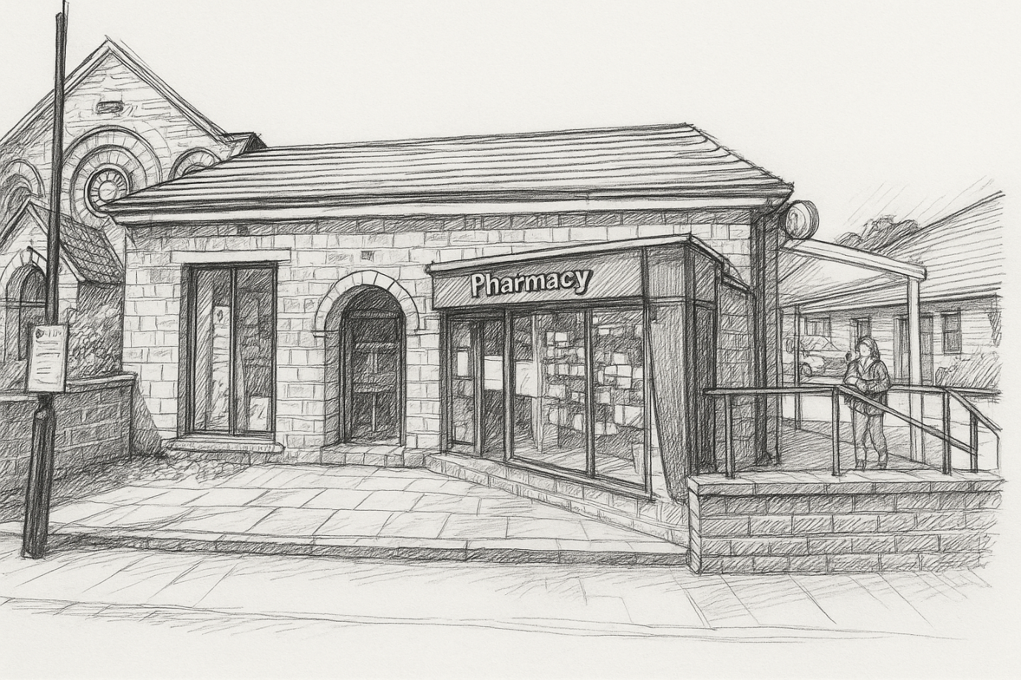
Figure 1: Former Primitive Methodist Chapel, Queen Street, Mosborough
Presently occupied by the community pharmacy of Gilbert and Armstrong, with a Post Office attached, several former tenants have been recorded at various times.
- Farewell Woodhead (1877-1948) was a boot and shoe repairer. He was first recorded at 36 Queen Street in the 1912 Edition of Kelly’s Directory of the West Riding of Yorkshire and continued to occupy the premises until his retirement around 1942.
- At this time (1941), the neighbouring property at No. 38 was tenanted by the British Legion (Mosborough) Branch.
- Kelly’s Directory of 1924 records that No. 38 Queen Street was occupied by Charles Gee (1872-19480), a former miner who became incapacitated, operating a hardware store.
- Thomas Henry Bolsover (1872-1949) ran a Fruit and Greengrocery store at No. 38 Queen Street around 1919.
- The premises are also said to have been occupied by the Eckington Leader, a local newspaper publisher and by the Eckington Co-operative Society.
Following a period of disuse, the building was taken over by building contractors Sloane and Roebuck, who used it as offices with a builders’ yard to the rear. Eventually, the pharmacists Gilbert and Armstrong had it refurbished in 1996 in advance of the transfer of their business from Mosborough High Street.
(From original research by David English)

