The Anderton Family of Mosborough (1633-1712)

By John Rotherham
April 2025

The Anderton family of Mosborough first appeared in local records in 1633 when, on 7th November, Ralph Anderton (c.1610-1678), a cordwainer (shoemaker), married Mary Inger at St. Peter and St. Paul, parish church, Eckington. His place of birth is unknown. In 1638, Ralph and Richard Anderton (d.1667), probably his older brother, were included in a roll or list of able-bodied men between the ages of sixteen and sixty to be called upon to defend the country in an emergency. The parish constables compiled the Derbyshire Muster roll for William, 3rd Earl of Devonshire, the new Lord Lieutenant of Derbyshire.
A year later, he was recorded as occupying a parcel of land at Mosborough Moor, known as Summerflatt. Ralph rose rapidly in social status and was elected Churchwarden at Eckington in 1638. A dispute in that year involved the four Churchwardens in petitioning the consistory court after parishioners failed to raise a levy for the repair of defects certified by the Bishop’s commissioners.
It is unclear whether Eckington became actively involved in the English Civil War, but at its outset, the manor was seized by the Puritan Parliament as crown property. Shortly afterwards, a complete survey in writing of the lands included in the manor was prepared for the use of Parliament. Ralph Anderton was recorded as the occupier of land on the south side of Hanging Lee Wood in Mosborough.
When Richard Anderton married Mary Savage in 1657, he left Eckington to practice as a Surgeon in Dronfield and conveyed his property on South Street, Mosborough, to his brother, Ralph. Included in this conveyance was a cottage and croft of 1 acre, stretching from South Street to High Street in the east, a typical historic narrow tenement plot in a part of the probable medieval settlement of Mosborough. Also included were several parcels of arable land in the common fields of Mosborough at Streetfield, Leefield and Park Hole.
Little is known of Richard’s surgical practice in Dronfield. Surgery in 17th-century Derbyshire, England, as in much of Europe during that period, was a rudimentary and often brutal affair compared to modern standards (Figure 1). It was often performed by barber surgeons, individuals who combined the roles of cutting hair, pulling teeth, and conducting basic surgical procedures. One notable influence during this century was the English Civil War (1642–1651), which affected Derbyshire due to its strategic location. The conflict increased the demand for surgical intervention to treat wounds from muskets, swords, and cannon fire.
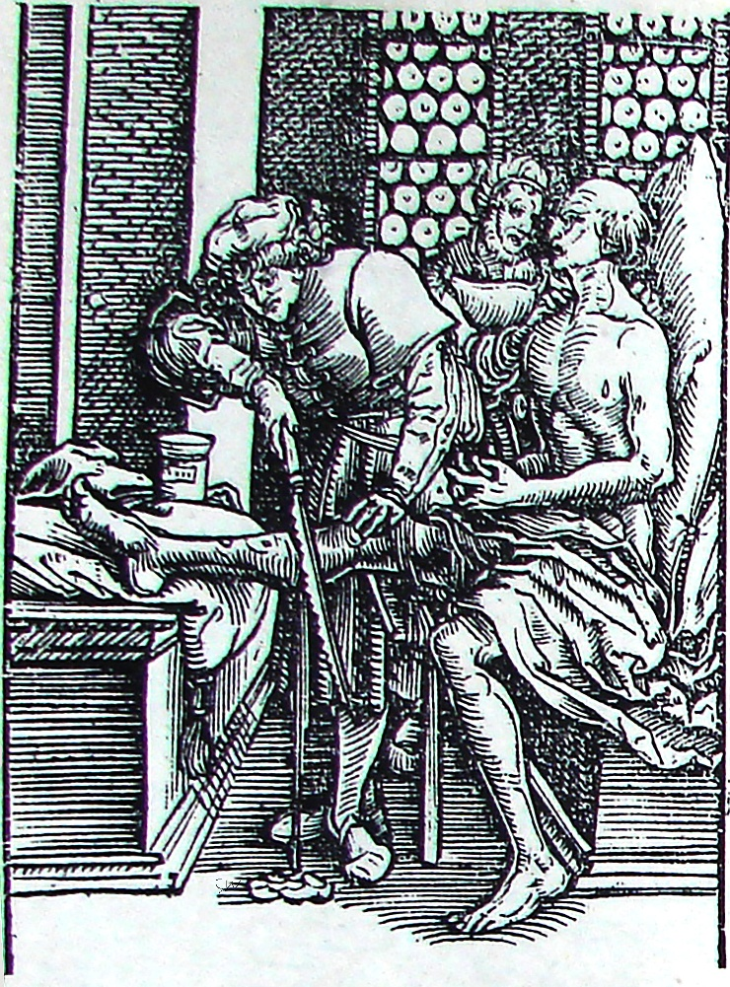
Figure 1. Medicine in 17th Century England. A surgeon amputating a man's leg in the days before anaesthetics
Richard died at Dronfield in 1667, and his wife Ann died there in 1664. Their two sons had probably died in infancy, so Richard's property in Dronfield came into the hands of Ralph and his wife.
The Hearth Tax, or Chimney Money as it was popularly called, a type of levy entirely new to England, was introduced in 1662. The return for Derbyshire in 1670 is retained at the Derbyshire County Record Office and contains entries for Eckington. Ralph Anderton is recorded as paying the tax for two hearths, indicating that he occupied a modest-sized house typical of a yeoman farmer's family in 1670.
When Ralph died in 1678, an inventory of his goods taken after his death revealed the value of his goods to be just under £30 (equivalent to approximately £3,340 at current prices). He and Mary occupied a two-storey house of four rooms with household furniture and utensils worth £17 and livestock and farm produce worth £13. Interestingly, the latter included 15s worth of coal.
When Ralph wrote his Will in 1677 at the age of about 68, he described himself as a Yeoman. He bequeathed all his personal effects, copyhold property and premises in Mosborough to his wife for the duration of her life and then to the younger of his two sons, John Anderton (1650-1684), thereafter. To his elder son, William Anderton (1643-1735), he left the estate at Dronfield, where William was then living. In addition, he bequeathed from his estate the sum of six shillings yearly to be distributed amongst the poor of Mosborough.
William and his wife Ann returned to the family home in Mosborough after the death of his mother in 1682 and his brother John in 1684. The couple remained there until William died in 1735 at the remarkable age of 92. Ann had died in 1712.

ANNEX A
Inventory of Ralph Anderton of Mosborough (1678)
A true and p’fect Inventory of all such goods Mr Ralph Anderton of Mosbrough in the p’ish of Eckington in the County of Derby Dyed ago about one….. and praysed by us as followeth July ye one and thirtieth day: one thousand six hundred seventy Eight. 1678
 | Imprimus | £ | s | d
 | His purse and Apparroll | 3 | 6 | 8
In ye house | A Range fire scumer and tonges barkhud and tasting Iron and pot hooks |  | 8 | 0
 | Two Iron pots and a posnit and an Irone Cottle a potlid |  | 14 | 0
 | Two smoothing Irons |  | 2 | 6
 | One brass pan and a Cottle and a mortar and a Candlestick |  | 6 | 8
 | Four pewter dishes 2 Candlesticks 3 saucers |  | 5 | 0
 | One longtable and 2 ould Chests and 2 chairs and a little table |  | 16 | 0
Item  In ye parlor | One long table two forms three buffits  one cubard  the books | 1  1 | 0  6  6 | 0  8  8
 | One range and a barbhud |  | 3 | 4
 | Two beds with there beding | 4 | 0 | 0
 | One prass and two Chaires |  | 12 | 0
Item in ye chamber ov’r parlor | One bed with ye beding  one Cradle and a Chest  the woole |  | 13  3  2 | 4  4  6
In ye chamber ov’r house | One bedstead 3 Arks and a Chest  One kimnel and a kneading trow  Mault and Wheat and wotmeale  One stone of Dow |  | 10  6  9  5 | 0  0  0  0
Item | A cow and a heffer | 5 | 10 | 0
Item | the sheep | 1 | 2 | 6
Item | One Aker of wheat | 2 | 0 | 0
 | One Aker of peas | 1 | 0 | 0
Item | The hoay in ye barne | 1 | 10 | 0
 | The Coals |  | 15 | 0
 | The mounor in ye foulde |  | 12 | 0
 | Two stone trows |  | 3 | 4
 | The pullon |  | 1 | 6
Item | All ye huslments |  | 12 | 0
 | Total su | 29 | 3 | 6

John Bingham
Thomas Newbould
James Lee
John Taylor

ANNEX B

Last Will and Testament of Ralph Anderton of Mosborough, yeoman (1677)

In the name of god Amen the eighth day of August in the yeare of our Lord god one thousand six hundred and seventy and seven in the twenty ninth yeare of the Raigne of our Sovraigne Lord Charles the second by the grace of god of England Scotland France and Ireland King defender of the faith I Raph Anderton of Mosbrough in the parish of Eckington and County of Derby yeoman being in good health of body and of perfect mind and memory praise therefore be given to all mighty god for the same I doe make and ordaine this my present last will and Testament in mannor and form following First and principally I comend my soule in to the hands of Almighty god my creator trusting through the merrits death and passion of my redeemer Jesus Christ to have full free pardon and forgiveness of all my sins I doe assure my self to inherit eternall happines with the blessed saints in glory and my body to the earth from whence it came to be decently buried in the Church or Churchyard of Eckington aforesaid And as for those worldly goods which it hath pleased Allmighty god to bestow upon me I give and bequeath as followeth Imprimis I have by surrender surrendered all my Coppy hould lands within the Manner of Ekington to feoffees in trust to and for such uses as I shall hereafter men’tn and express in this my last and Testament Now my will and mind is and I doe expressely give unto Mary Anderton my loving wife all my said lands of Coppy hould and Tenaments whatsoever with the Appruten’ces lying and being within the Mann’r of Eckington aforesaid during her widowhood or for soe laong as she continueth in my name After her decease then I doe give and bequeath all my said lands and Tenam’ts in Mosbrough affore said unto John Anderton my sonne and to the heires of his body lawfully begotten or to be begotten And for default of such issue then to the use and behoof of the right heires of William Anderton my sonne and to his heires of his body lawfully begotten or to be begotten and for default of such issue then to the use and behoof of the right heires of me the said Raph Anderton for ever. But if it please god that my sonne John Anderton and my sonne William Anderton shall happen to dye without any issue then my will and mind is that the right heires of mee Raph Anderton after their decease shall pay or raise to be paid unto Mary Weakland and Ann Garland to either of them theire heires or assignes the full and ….. sum of forty pounds of lawfull English money so soone as they shall enter to the said lands and Tenaments in Mosborough affore said Item I give and bequeath unto the Churchwardens and overseers of the Town and Parrish of Eckington afforesaid and to their successors for ever a Moyety or yearly rent of six shillings to be paid unto them fourth of my said lands in Mosbrough afforesaid it being bequeathed formerly and given by James Couley to be distributed to and amongst the most needful of poore inhabitants within the Barlow of Mosbrough afforesaid upon every good Friday for ever But if default bee made in payment of the said sume of six shillngs yearly or any part thereof at the day and time affores’d that then ……. of them shall enter into all or any part of my afforesaid lands and distrain for the same and for every distresse so taken shall pay unto the s’d Churchwardens Two shillings or the full sum of six shillings and the same to be distributed to and amongst the most needful poore in Morbrough afforesaid Item I give and bequeath unto Mary Anderton my loveing wife all those Messuages Cottages Lands and premises in Dranfield during her widow hoode which Lands are now in the occupation of William Anderton my sonne But if shee either dye or marry Then to returne to William Anderton affores’d and to his heires for ever paying to Mary Weakland my Grandchild four pounds soe soone as she shall accomplish the yeares of one and twenty and if it fortune that she dye or be not married then to the use and behoof of William Anderton and John Anderton my sonnes Item I doe give and bequeath unto Thomas Garland my sonne in law and to Anne his wife either of them tenn shillings in full satisfaction of all dues and demands from mee whatsoever to be p’d within twelve moneths after my decease Item I give and bequeath unto Mary Garland my Grandchild four pounds to bee paid by William Anderton my sonne fourth of my said lands in Dranfield affores’d And to be put fourth for the best advantage of her soo soon as she shall attain to the age of seven yeares Item I give and bequeath unto Richard Anderton and Lilly Anderton my Grandchildren either of them tenn shillings to be paid by my Executrix hereafter named And further my will and mind is that Mary Anderton my loveing wife shall pay yearely and every yeare unto John Anderton my sonne upon his good beehaviour the sume of twenty shillings of lawfully English money at Whitsunday and St Martin in Winter by even portions after my decease Item All the rest and residue of my personall estate goods and chattels whatsoever I give and bequeath unto Mary Anderton my Loveing wife And I doo make her full Executrix of this my Last will and Testament Revoakeing all other Wills and Testam’ts formerly made by mee And I doo desire Thomas Taylor of harthill and George Savage of the haven to be supervisors of this my last Will and Testament desiring them as I trust them to bee aiding and assisting to my Executrix affore named and I give unto either of them three shillings for their care and paines All legacies given and exxpressed by mee in these presents I doe give them in full satisfaction of all dues and demands whatsoever or howsoever the same beecame due from mee In Witness whereof I have hereunto set to my hand and seale the day and yeare first above written.

Sealed signed and acknowledged to be Raph Anderton his mark
my last Will and Testament in the presence of

George Savage
John Renshaw his marke
Fra: Greaves

Inger may be a mistranscription of Ingram.
The Anderton surname originates in Anderton, Chorley, Lancashire, northwest of Bolton.
The National Archives, SP 16/405, ff. 90-218. Ralph and Richard were among the 352 Eckington men listed in the roll. Rosewarne, V.A., The Derbyshire Musters of 1638-9, Part 2, p. 21.
5th November 1634. Garratt, H.J.H., Eckington, The Court Rolls, Vol. IV, p 18.
Staffordshire Record Office, B/C/5/1638/33, 1638.
Hall, T.W., Court Roll and Parliamentary Survey of the Manor of Eckington, 1924, p. 71.
27th January 1657. Garratt, H.J.H., Eckington, The Court Rolls, Vol. IV, p. 60.
Derbyshire Record Office, D5852
Annex A. Inventory of Ralph Anderton of Mosborough (1678)
A house and a parlour with chambers over each,
Annex B. Last Will and Testament of Ralph Anderton of Mosborough, yeoman (1677). He signed his Will by mark.
A "Yeoman" in seventeenth-century England could be described as a free man who owned and cultivated his land, freehold or leasehold. Ranked below the gentry but above tenant farmers and labourers and often prosperous, they were generally respected members of their communities.
His advanced age was of such significance that it was recorded in the parish register.

