Richard Davies (1838-1901), Master of the Mosborough Endowed (C.E.) Schools, and the pupil attendance row of 1876.

John Rotherham
March 2023

Richard Davies (1839-1901) was born in Llanelly in Wales in Wales, the son of William Davies (1814-1904), sawyer, of Llanelly, and his wife Sarah (formerly Samuel, 1817-1907). By the age of 22. Richard had qualified as a Certificated Teacher and was teaching at a small school at Llanddarog, a village on the outskirts of Carmarthen., He married Mary Ann Durston (1847-1929), the 23-year-old daughter of James Durston, a gardener, of Ystradgynlais, Breconshire, on 17th February 1870.
It was around this time that he took a teaching post at Oddfellows Street National School in Ystradgynlais, South Wales, a coal and ironstone mining area, where Mary Ann also became its schoolmistress. It was here that their first child, Minnie, was born in 1871. The couple moved to Mosborough in October 1874, when Richard was appointed Master of the Mosborough Endowed (C.E.) School, following the resignation of the former master, William Ascough.
The school was situated in the heart of the village (see Figure 1) occupying an area of approximately one and a half acres, including the old schoolhouse on the opposite side of School Street (see Figures 2 and 3). The building has been converted in recent years to a community centre, now known as the Joseph Stones Centre. The old schoolhouse was sold to private owners in 1935.
Figure 1: The Joseph Stones Centre (formerly the Mosborough Endowed Schools)
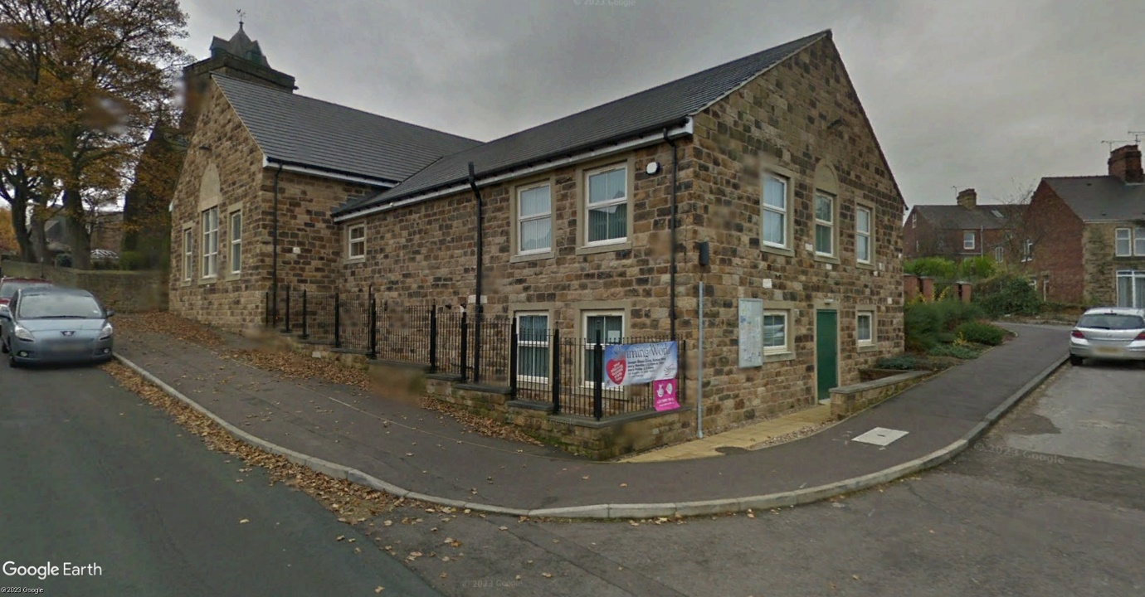
Founded in 1680 under the terms of the will of Joseph Stones, lead merchant, of Mosborough Hall, the school comprised a cottage and lands with trustees responsible for the appointment of a schoolmaster and the teaching of 15 poor children living within the village.
Figure 2: The Old Schoolhouse, School Street, Mosborough
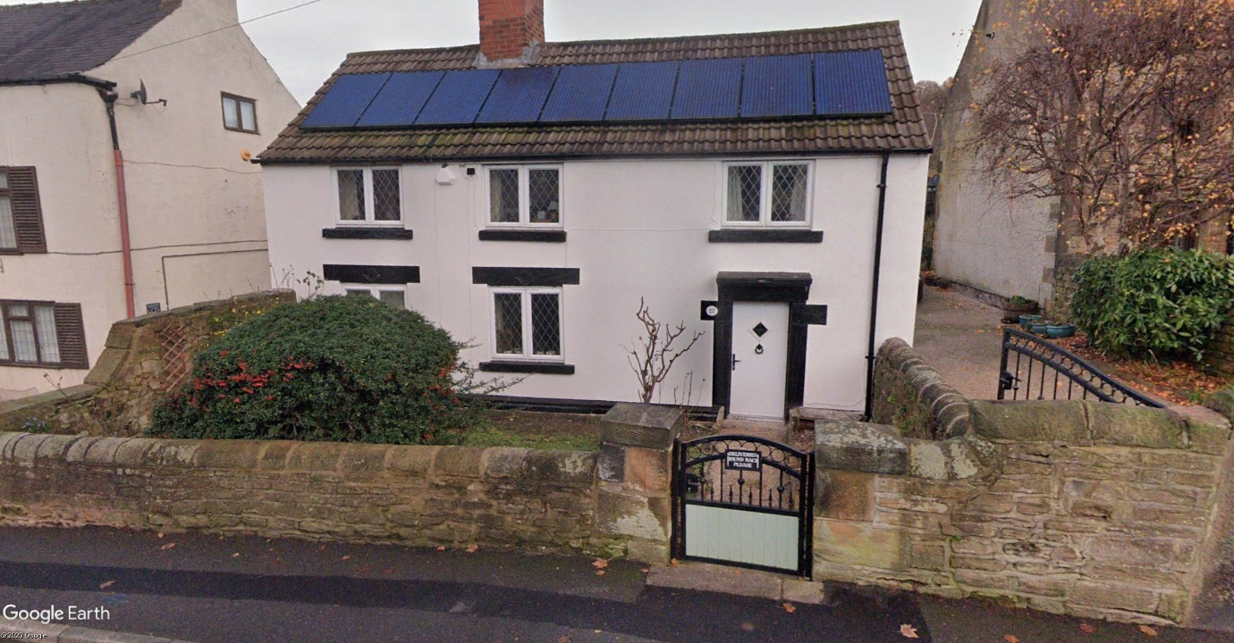
Figure 3. Site of the Mosborough Endowed School in 1875 and land (edged red) held by the school trustees at the time of the Eckington Enclosure Act in 1795.
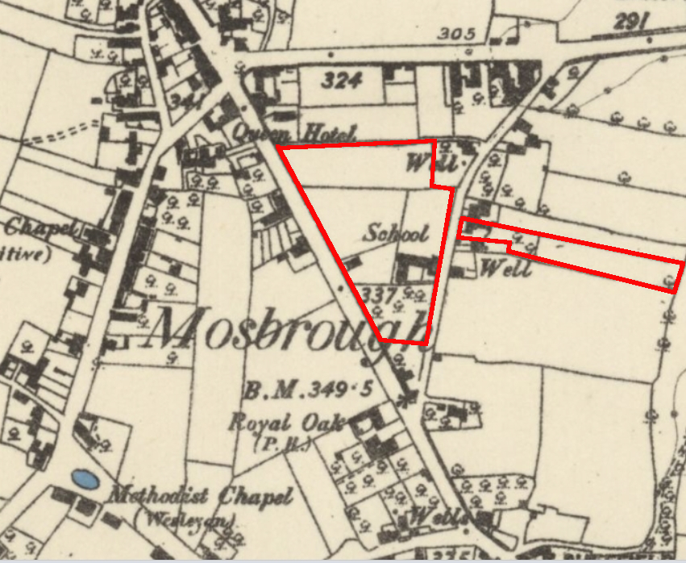
The school had a chequered and eventful history, even to the extent of provoking village riots in 1782 and 1791. Suffice it to say that by 1822, the schoolhouse had become so dilapidated that it was decided that a new school should be built on the opposite side of School Street, eventually becoming the new Mosborough Endowed School. In total, the work was completed for £131, including the restoration of the schoolmaster’s house. The school was very considerably enlarged in 1871, with the aid of a loan of £650 from the Thomas Camm School Trust of Eckington.
Following his appointment, Richard set about the reorganisation of the school. In 1875, he established a separate department for the teaching of infants, and appointed his wife, Mary Ann, to be the mistress. Their second daughter, Mary Gwenllian, was born on 12th January 1876.
Some eighteen months later, he became embroiled in a controversy surrounding school attendance. In May 1876, Richard Booth of Ford, the School Attendance Officer, presented a report to the Eckington School Board, claiming that 100 children were kept from school by their parents on account of the “austerity of the Mosborough schoolmaster”. This rather incendiary statement was accurate, though it should be viewed in the context of a unique set of circumstances.
On his appointment, Richard had been instructed by the Reverend E.B. Estcourt, Rector of Eckington and a trustee of the school, to collect the fees for the fuel used at the school from every pupil, something Richard’s predecessor had failed to do. Furthermore, the trustees had decided to increase the fee from 4d. to 6d for the season, due to the high price of coal. No such fees were payable by pupils of the new Board schools, with the consequence that children were withdrawn from the school and complaints were made regarding the master’s firm discipline.
In effect, Richard seems to have taken over a failing school, and he was prompted to make a robust response to the criticism of his leadership in letters to the Editors of the Sheffield Daily Telegraph and the Sheffield Independent ten days later. He apparently feared being regarded as a scapegoat for the failings of others, particularly the reluctance of the School Board and its officer to pursue prosecutions for non-attendance in Mosborough, because there was no Board School there to benefit from it. He also drew attention to the deficiency of school places in Mosborough, of which the School Board were well aware.
Richard’s letter brought a quick response from George Henry Wells of Southgate House, the Vice-Chairman of the Eckington School Board, who sought to justify the Board’s apparent lack of interest in pursuing prosecutions for the non-attendance of pupils. In letters to the Sheffield Independent and the Sheffield Daily Telegraph he claimed that when cases had been brought before the magistrates, convictions could not be granted unless there were available places in the relevant school. This presented a particular difficulty for the Board in Mosborough as the accommodation was insufficient. He claimed that the Board’s intention to provide a new school in the village had been deferred after representations from the Rector of Eckington, who requested an opportunity for the Church of England to remedy the deficiency itself; an aim they had been unable to accomplish.
Furthermore, Wells sought to distinguish between the present Master and his predecessor, suggesting that the present Master should recognize that discipline does not mean severity, but that he should rather temper kindness with firmness.
A week later, in a letter to the Editors of the Sheffield Independent and the Sheffield Daily Telegraph, the Reverend E. B. Estcourt, as a trustee of the school, sought to respond to the statements of the School Attendance Officer and the letter of George Henry Wells. He disputed Wells’ assertion that the school’s performance was superior when the late master was in charge, citing a report of Her Majesty’s Inspector for 1873, in which the following statements appeared: “The children under seven were very backward, undisciplined and ill-taught” and “The registers have been kept in a very careless and slovenly manner”.
In contrast, he quoted the most recent Government inspection report “Mosborough Church of England School:- Discipline and order fair; satisfactory progress has been made during the year. The children have been intelligently taught. Infant School: This school is in a creditable state of efficiency.” He also compared the average attendance in 1873/4 when Mr Ascough was the master, which had been 170, with the 1875/6 average attendance of 157, securing the highest grant the school had received since it was placed under Government inspection.
Shortly afterwards, and springing to his defence, William Ascough, the former Master and now Clerk to the Eckington School Board, wrote to the Editor of the Sheffield Independentobjecting to the comparisons that had been drawn between himself and his successor. Firstly, during his tenure, there had been no certificated mistress at the school as was the case currently, so it could hardly come as any surprise that the present master could achieve a higher standard. This deficiency had been drawn to the attention of Mr Estcourt by the inspector at the time, stating that no teacher could do justice to his elder children and superintend the infants also.
Ascough also hinted that the Rev. Estcourt had been selective in his quotations from the 1873 inspection report, recalling that it also said “1. Discipline and order fair – considerable progress has been made in every respect”. “2. Mr Ascough possesses skill as a teacher, and his school is in a very fair state of efficiency”. “3. Order in 1 and 2 is improved, and the slate work was very neatly done”. He suggested that if the Rev. Estcourt doubted his ability, it was questionable why he should have offered him the opportunity to succeed Mr Harrison at Camm’s school, and why, on leaving the Mosborough school he had written “You have been so popular with parents and children, and the school has prospered so much in every respect, while under your charge, that we shall be sorry to lose you”.
It was a spirited defence of his reputation, backed up by a further letter from George Henry Wells, which appeared in the same edition of the Sheffield Independent. Wells stated that he had not intended to question the “scholastic attainments” of the respective masters, but rather to draw attention to the “manner of treatment”. Suggesting perhaps that there was some political motive for the debate, he said he cared not for how the Rector may interpret the actions of the School Board, “or as to the motives with which he and the party he represents may credit us”.
It is noteworthy that in early 1876, the Eckington School Board had already commenced the building of a new school at Halfway to serve the Mosborough area. Perhaps the monopolistic influence of the Church of England on education was coming to an end.
In January 1880, Richard and Mary Ann’s third child, Ethel Mary, was born. According to the 1881 Census, the family were living at Sheffield Road, Mosborough (now High Street), suggesting they were living in the new master’s residence, attached to the 1871 school building (see Figure 4).
Figure 4. School Master’s House, Sheffield Road, Mosborough.
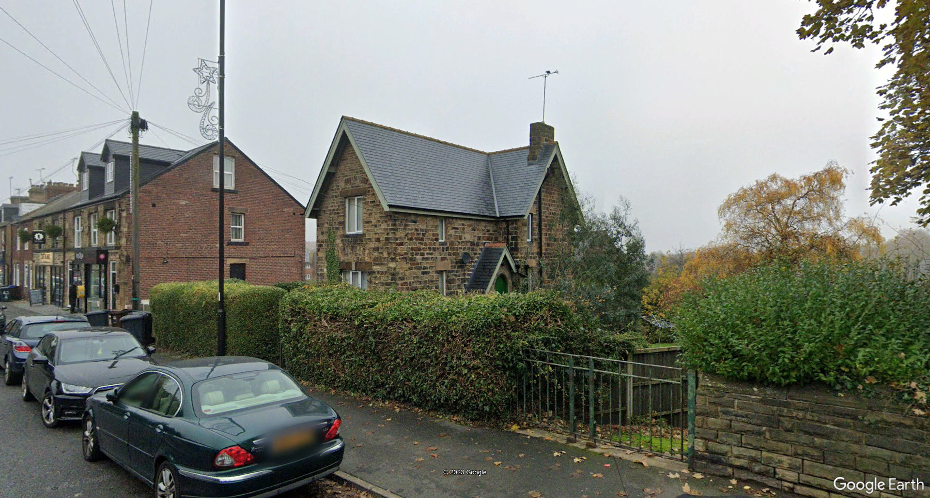
Richard and Mary Ann had a fourth child, Lilian, born on 31st August 1883 and baptized at St. Mark’s Mosborough the following October. Unfortunately, Lilian died in 1887, aged 4, and was buried at Eckington Cemetery.
Richard Davies proved to be an efficient teacher and a respected member of his local community. He was a member of the East Derbyshire Teachers Association, becoming its President in 1892. An active churchman, he was a sidesman, lay preacher and treasurer of St. Mark’s Church, Mosborough, and secretary/treasurer of the Mosborough Workmen’s Club since its formation.
He resigned as Headteacher of the school on 31st December 1900 when he became ill and died two weeks later, aged 62. Had he lived he was to have received an illuminated address and a purse of money in recognition of his work in the church and community.
Richard was succeeded as headmaster of the Mosborough Endowed Schools by William Henry Holmes (1872-1939), who married Richard’s daughter, Margaret Gwenllian, in December 1901.

Mosborough Junior School Log Book, 1874.
5th April 1875. Mosborough School Log Book 1875.
Eckington Parish Register.
Sheffield Independent, 19th May 1876. School Boards were created for every parish in England under the Elementary Education Act, 1870. The Eckington School Board was made up of seven members elected by the ratepayers and covered the whole of the Eckington parish including Troway, Ridgway, Eckington, Mosborough and Renishaw.
Richard had, at his own volition, raised the fee to 9d, but was obliged to reduce it to 6d in consequence of representations, before the consent of the trustees had been given.
Sheffield Daily Telegraph, 29th May 1876.
Sheffield Independent, 30th May 1876.
Sheffield Independent, 13th May 1871. An early assessment of pupil capacity by the newly formed Eckington School Board in 1871, estimated that additional accommodation was required for 143 pupils in Mosborough.
Sheffield Independent, 3rd June 1876.
Sheffield Daily Telegraph, 3rd June 1876.
The Endowed School in Mosborough was founded as an educational charitable foundation under the terms of the Will of Joseph Stones, gentleman, of Mosborough Hall, of 1680. The Church of England became involved in the running of the school in 1822 under an Order of the Court of Chancery.
A grant (or loan) of £650 had been advanced to the Mosborough School Charity Trustees by the Rev. E. B. Estcourt in 1871) for the purpose of enlarging the school to make provision for 414 scholars. (Sheffield Independent, 19th May 1871, and D.R.O. D6564/3/6, Charity Commission statement, 1st August 1871
Sheffield Daily Telegraph, 10th June 1876.
Sheffield Independent, 10th June 1876.
Sheffield Independent, 17th June 1876. William Ascough had been appointed to the newly-created post of Clerk to the Eckington School Board in 1871, a position he occupied alongside his duties as Master of the Mosborough Schools.
Sheffield Independent, 19th May 1876. At it’s meeting in May 1876, the School Board approved the first instalment of £200 to Messrs. Fidler Bros. for the building of the Mosborough Board School at Halfway, which opened in 1877..
Sheffield Daily Telegraph, 18th January 1901.
Sheffield Daily Telegraph, 24 December 1901.

