By Royal Appointment: Charles John Rotherham (1838 – 1922) of Mosborough, Queen Victoria’s Canine Surgeon

By John Rotherham
January 2021

The Rotherham family has been associated with the manor and parish of Eckington since the late 15th Century. While many local families chose to migrate, the Rotherham’s stuck firmly to their roots, demonstrating a distinct lack of imagination, which (according to his wife) the writer shares with his ancestors!
However, the marriage of John Rotherham and Martha Cooper at the parish church of St Peter and St. Paul, Eckington, in 1803, was to be the foundation of a branch of the family that broke the mould. The sons of this union, particularly Charles, John, Henry and Alexander, became successful entrepreneurs in the London wine and spirits trade; Charles having accumulated sufficient wealth to acquire Mosborough Hall on his return to Mosborough in 1844.
John and Martha inherited the family farm on East Street, Mosborough, when John’s father, Samuel, died in 1814. It was one of their younger, and arguably less ambitious sons, Edward (Edwin), who stayed home to take over the farm when his brothers set off for London to make their fortunes.
Edward was born in 1816 and married Louisa Hibbs (by licence) at St Peter and St Paul parish church, Eckington, on 18th February 1836, when Louisa was just fifteen years old. Over the next twenty years, the couple had nine children; three sons and six daughters. It is their eldest son, Charles John, who is the subject of this account.
Charles John Rotherham was baptised at St Peter and St Paul parish church, Eckington, on 16th August 1838. The 1841 Census records him, aged three years, living at East Street, Mosborough with his father and mother, sisters Eleanora Elizabeth (age 5) and Martha (1 month), along with his uncle, Alexander who, at the age of 20, is already in business as a Spirits Merchant.
By the time of the 1851 Census, Charles (then aged 12) was attending the private boarding school of Mr. Edward Barber in Sunderland Street, Tickhill. It may not be entirely coincidental that the activities taking place a couple of doors away at Mr. Charles Sayles' veterinary surgery had a formative effect on his early years.
However, this aspect of Charles’s career did not become evident until later, for in 1860, he married Harriet Mounsey (b. 1839), daughter of the late Samuel Mounsey, landlord of “The Sawmaker” pub in Russell Street, Sheffield, now known by the name of “The Kelham Island Tavern”.
Figure 1. Kelham Island Tavern (c. 2014), formerly “The Sawmaker”, Russell Street, Sheffield.
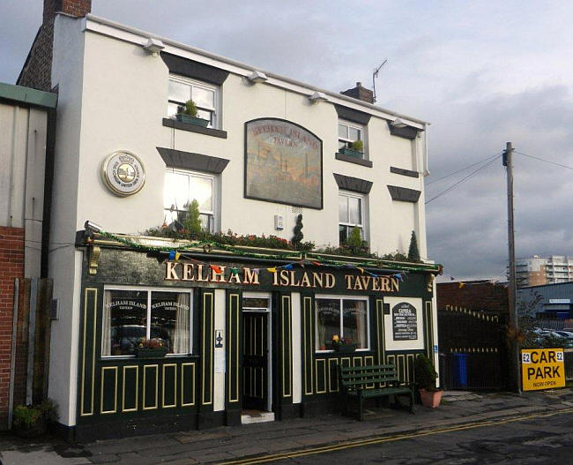
The couple set up a home nearby at Rock Street in Sheffield Brightside, close to the Sheffield steel-making industry's heart. At around the same time, their first child, Matilda Ann, was born. Charles secured a post as a commercial traveller with a file and steel manufacturing company, but the work was evidently not to his liking. Shortly after his daughter, Alice was born in 1864, he had moved to London, and the “Blue Posts” public house in Berwick Street, Soho.
Probably, this change of direction was no coincidence. Charles’ uncles had been Licensed Victuallers and Wines and Spirits Merchants in the London’s St James’ district since the late 1820s. His sister, Martha Ann, had been tutored by Amelia Hodgson, the governess at Mosborough Hall, alongside his cousin Cornelia (who was Henry Rotherham's daughter, landlord of the “The George”, 23 Crown Street, Soho). Family influence was coming to bear.
In 1849, another of his uncles, John Rotherham, had transferred the licence for “The Silver Street Coffee House”, which he operated in St. James to a Thomas Swallow of Rotherham. Swallow’s son, George Thomas Swallow, was to marry Charles’ sister, Martha Ann, ten years later. Maybe it was his sister’s move to London with her husband that proved the catalyst for Charles to do the same, for it was Swallow who was to become Charles’s partner in “The Blue Posts” public house shortly afterward.
The trading partnership of Rotherham & Swallow was to be short-lived, however. Swallow accrued substantial debts, and in August 1866, the partnership was dissolved by mutual consent. Shortly afterward, Charles took a transfer of the licence for the “Valiant Trooper” 9 Goodge Street, St. Pancras trading as Rotherham & Co. This enterprise also proved to be a failure, and Charles was out of business and bankrupt by January 1868, moving temporarily next door to 8 Goodge Street.
The next few years were to be challenging. In April 1869, his younger sister, Lucy Catherine, aged 19, died at their parents’ house, now in Harthill, followed by the death of his much-respected father, Edward, in September. As he struggled to make his way in London, his wife and their children remained in Sheffield, at the home of her sister, Emma, at Pyebank Road, Brightside. Tragically, Harriet too died in October 1871 at the age of just 31.
It was time for a reappraisal. Perhaps Charles’ early life as a farmer’s son and his observation of the veterinary surgery activities adjoining his boarding school that inspired a career in veterinary practice. Combining a single-parent role with that of a professional traineeship in the Metropolis must have been difficult. It seems likely that the children would have remained with relatives in Sheffield, while Charles took lodgings in London. It was here that he was to meet and fall in love with his future wife, Susan Pratt.
The 1861 Census reveals that Susan (formerly Murrin), the wife of Cabinet Maker and Upholsterer, George Pratt, who had established a successful business employing six men, lived at 12 Denmark Street, St Giles, a house in multiple occupation. George Pratt died in 1871, and Susan records herself as a lodging house keeper at the same address in the Census of 1871. When Charles and Susan marry, just around the corner at St Giles in the Fields in October 1873, they both describe their address as 12 Denmark Street, which possibly implies that Charles had taken lodgings with Susan and that this was how they became acquainted. Their marriage certificate records Charles’ rank or profession as a veterinary surgeon.
It soon became evident that canine surgery was to become his niche. The veterinary profession was largely horse-focused, and there was little demand for the treatment of cats, dogs and other pets. However, several specialist canine vets had been operating in London since the early part of the Nineteenth Century.
Charles aspired to serve the wealthy and famous amongst his clientele. The 1873 Electoral Register for St George, Hanover Square, records his address as 82 Grosvenor Street, Mayfair, an area described as 'a spacious well-built Street, inhabited chiefly by People of Distinction', at its laying out in 1735. He is clearly defined as of that address in a report in the London Daily News in September 1874 when he gave Marlborough Street Police Court evidence about cruelty to a dog.
His reputation first came to public attention in a report on the Crystal Palace Dog Show in 1872, when the condition of the prize-winning Mastiff ‘Turk’ and others was attributed to his treatment method at the hospital for sick dogs at Shepherd’s Bush.
A newspaper advertisement in 1874 described the Grosvenor Street address rather grandly as “the Royal Canine Infirmary”, but this was not merely pompous frippery. Queen Victoria was famously fond of her dogs. She was noted for her affection for her animals and her gratitude to those who eased their suffering. It is not known just how Charles secured an introduction to the Royal Court, but, according to an aside to a lady exhibitor many years later, it was on the occasion of saving the life of the Queen’s collie “Noble”. It was reputed that she doubled her usual cheque for services rendered and granted Charles the much-coveted Royal Warrant.
This rapid rise to prominence was no accident. The location of Charles’ premises, alongside the dentists and surgeons of Lower Grosvenor Street, at the junction with New Bond Street, was well placed to catch passers-by's attention in this fashionable district of London. His services to clients extended beyond that of veterinary surgery. He was often known to handle the sometimes-murky trade of offering rewards for the return of lost dogs, securing dams or sires for breeding purposes , or the sale of pedigree litters.
With his growing reputation came several invitations for product endorsements, including those of Ashworth’s Metallic Comb and Brush, Clarke’s Buffalomeat Dog Biscuits, and Jeyes’ Disinfectant Dog Soap. But celebrity often comes at a cost. In January 1876, he was obliged to publish a disclaimer when a prisoner mentioned his name connected with a dog stealing case. A few years later, he offered a reward for information about the author of false reports that he had removed from his premises, and an American detractor referred to him obliquely as “Poodle Clipper to the Prince of Wales”.
Figure 2: Advertisement in The British Mail, 1st March 1879. Charles Rotherham’s endorsement of Clarke’s Buffalomeat Dog Biscuits.
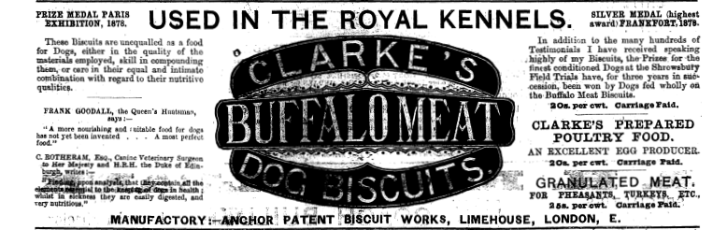
However, these were little more than minor distractions from his advancing reputation and career in veterinary practice. In June 1880, he gave evidence before the Court of Common Pleas, sitting at Westminster Hall, in an alleged libel case. The action involved the publication in “The Field” and the “Fanciers’ Chronicle” of a statement about the condition of a bloodhound named “Napier”. The animal had appeared at a dog show at Alexandra Palace in July 1879. It was alleged that the dog’s eyes seemed to have been tampered with. Charles reported that he had conducted a partial operation to remove an excrescence or morbid growth on the haw (a membrane of the eye, commonly referred to as the third eyelid in dogs) in April of that year. He said that the operation would have healed within a few days, and the result would not have been visible at the show. He never heard such a procedure as he performed called “tampering” with the animal. The Court dismissed the case.
Around 1878, Charles had moved his premises a few streets away to 55 South Molton Street, Mayfair, which was to become the permanent address of his surgery for the next thirty years. It was a street populated by hairdressers, tailors, milliners, dressmakers and hatters, an ideal location to capture his target market, the devoted lady owners of privileged dogs. A Scottish contributor to the U.S. Journal Forest and Stream wrote this in 1884:
“Seeing some time ago an enquiry about deerhounds in FOREST AND STREAM I beg to inform your readers that I know of no one in the old country who knows better where to lay his hands on the real article than Mr. Rotherham V.S., Royal Canine Surgery, 55 South Molton Street, London. I have known him for over twenty years as a gentleman of honor, and any American sportsman calling at the above address will receive every kindness and information regarding any breed of the canine”.
The rate books for 1881 recorded 55 South Malton Street as a house and shop. The Census for that year reveals that the domestic accommodation was occupied by an American gentleman of independent means and his family and servants. Meanwhile, it seems that Charles had taken a tenancy of The Grange, a large property in Neasden, once nicknamed “the loneliest village in London”. The house was described as “a charming cottage residence, with drawing, dining and breakfast rooms, eight bedrooms, bathroom, butler’s pantry, kitchen, larder and other domestic offices.” Although some six miles from central London, it was just a two-minute walk to the new Neasden Station on the Metropolitan Railway, with Baker Street Station being a 15-minute train journey away.
Living at The Grange on census night 1881 were Charles (43) and his wife, Susan (48), along with their daughters, Matilda Ann (20) and Alice (17). Also living at the house were three servants, Ada Kingshot, General Domestic Servant (18), Arthur Crissell, Veterinary Assistant (19) and Harry Agate, Stableman/Groom (20).
There were three visitors to The Grange on that evening: Edgar Walton Roberts, Wine Merchant (who was to become the husband of Matilda Ann later that year), Charles T. Hall, Commission Agent and former Wine Merchant and Richard Harold Cummings, Professor of Singing at the Royal Academy of Music. One could imagine that the Butler’s Pantry would have been well-stocked! Perhaps daughters, Matilda Ann and Alice, were receiving singing lessons.
1881 was also to see a significant change in the practice of veterinary surgery. The Royal College of Veterinary Surgeons was established by Royal Charter in 1844 in part to restrict the title of ‘veterinary surgeon’ to those who were qualified by examination. There were growing concerns within the profession about the numbers of unqualified individuals of questionable competence, Charles amongst them, who were assuming the title outside the qualification/registration framework.

Figure 2: The Grange, Neasden. Built in the early years of the Eighteenth Century, The Grange is thought to have been among the farm outbuildings of The Grove, a large house lying just to the south. It was converted to residential use around 1845 and is now a conference and training centre with serviced office accommodation.
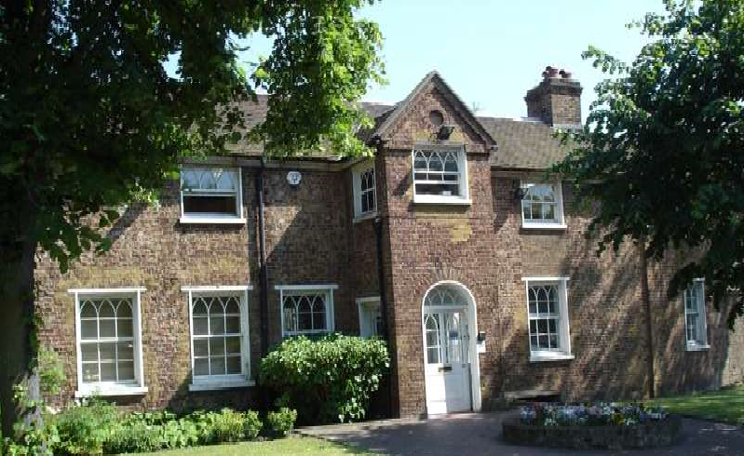
In September 1881, it was announced in The Morning Post that Matilda Ann was to be married to Edgar Walton Roberts at Willesden Parish Church.
The 1881 Veterinary Surgeons Act granted those with the requisite qualifications the exclusive right to the title ‘veterinary surgeon’ and sought to regulate unqualified practitioners' activities. To this end, the Act established a register of “Existing Practitioners” (effectively Licentiates of the Royal College of Veterinary Surgeons), which was to remain open for applications for one year from the Act's passing.
By this time, Charles had acquired the necessary five years of continued veterinary practice to apply for registration and lodged his application with the College in 1882. The Act also required the testimony of good moral character and integrity. For this, Charles was able to enlist his veterinary colleague of sixteen years, George South.
By 1883, it seems that he may have also taken a lease of The Grove, a substantial house lying to the south of The Grange, for he was offering The Grange for rent with six loose boxes, two coach houses, harness room, poultry house and large brewhouse, quoting an unexpired lease of eleven years. Shortly afterward, his wife Susan placed an advertisement in The Morning Post seeking a young Belgian or German woman with good English as a cook and servant to a small family.
A notice in the St. James Gazette announced the marriage in November 1885 of Charles’ second daughter, Alice, to Walter Alfred Beevor Potts, at Willesden Parish Church. The couple would settle and have two children at Vicarage Villas, Willesden, before immigrating to Australia.
Figure 4: The Grove, Neasden. This fine house was demolished in 1939.
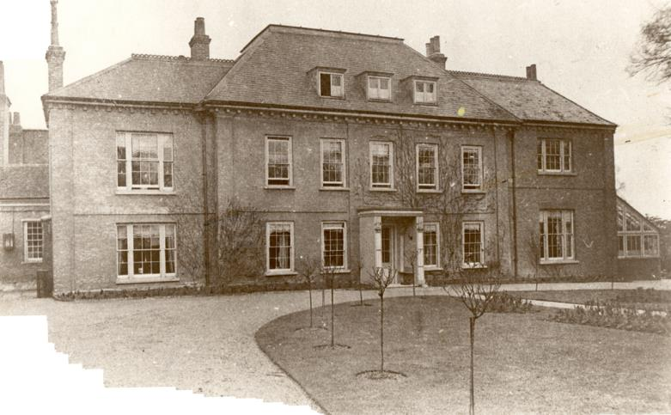
Around this time there were growing concerns about the incidence of rabies, and its associate human condition, hydrophobia, since the 1830s. Public hysteria, fuelled by dramatic press accounts of ‘mad dog’ incidents, had reached crisis proportions in 1885. Notified deaths from hydrophobia doubled to 60. A controversy had raged for decades among medical and veterinary professionals about the most effective means of controlling and treating rabies. Now, attention was turning to its complete eradication. There was a substantial body of opinion that favoured all dogs' muzzling to stamp out the disease completely. In response, Sir Edmund Henderson, the Metropolitan Police Commissioner, issued an order under the Metropolitan Police Act, 1867, for all dogs on the street to be muzzled or led. He also warned that all stray dogs would be seized, taken to the Dog’s Home, and killed if not claimed. In December 1885, more than 9,000 dogs had been seized by police in London in one month alone. Naturally, this led to an outcry amongst the dog-loving residents of the Metropolis. Charles did not support this establishment-led approach and made his views known in a letter to the Illustrated Sporting and Dramatic News “as an old canine surgeon, with a practice which has extended over a period of twenty-four years” in which he argued that muzzling was both cruel and unnecessary.
It was no secret that the Queen had taken a deep interest in the question on which Charles had stated his views and that Her Majesty, who sympathised with the suffering caused to dogs by the muzzling regulations, had expressed a desire to hear his opinion. When a dog was killed in the street by police, having thrown off its muzzle, the Queen was rumoured to have written to the Chief Commissioner to ask if such brutal methods were necessary. In a letter written at Osborne, she speaks of Charles as “my intelligent clean Doctor…. understanding of dogs and cats, who she consults whenever hers are unwell”.
Somewhat embarrassingly, in June 1885, it seems that Charles somehow managed to lose the Queen’s Royal Warrant on his way between Regent Street and his Malton Street Surgery. Whether he received a response to his appeal for its return with the offer of a Ten Pounds reward is not recorded.
A plate in M. B. Wynn’s History of the Mastiff (attached) reveals the extent of Charles Rotherham’s impressive client list at “the London Royal Canine Surgery and Hospital” in 1886. In addition to H. M. The Queen, it includes Albert and Maria, Duke and Duchess of Edinburgh; Prince George, Duke of Cambridge; Alexander III, Emperor of Russia; the Grand Duke Alexis of Russia; Princess Frederica of Hanover, Abdul Hamid II, Sultan of Turkey; Alfonso, King of Spain; the Maharaja Duleep Singh of the Sikh Empire and Prince Albert of Solms-Braunfels, along with the leading aristocracy and gentry of Europe. Charles is described here as a “Professor of Canine Pathology”.
A notice in the London Standard extolled the range of services available:
Notice – Dogs – Mr Rotherham, veterinary surgeon and canine pathologist, by special appointment to H.M. The Queen and Royal Family, may be consulted from 2.00 until 5.30 daily, Saturdays and Sundays excepted, upon 3 days by appointment. Fees 2s 6d. or by letter 3s 6d. Suspected cases of rabies examined free of charge. The Royal Canine Surgery, 55 South Molton Street, Bond Street. The Hospital, most healthily situated near Harrow on the Hill, has well ventilated and spacious kennels for large dogs and every home comfort for a pet dog. The exercising ground covers 50 acres.
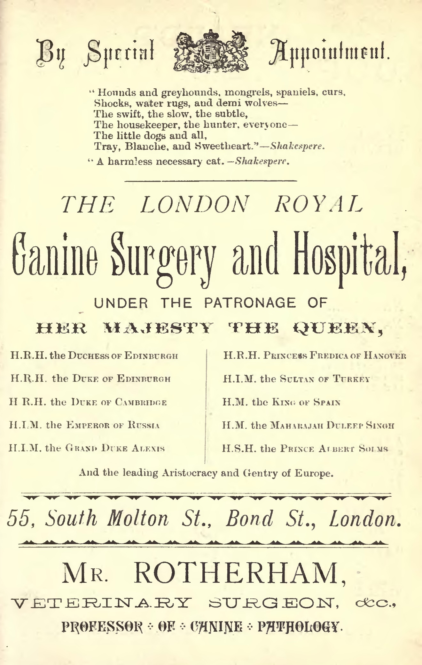
In May 1887, the Government appointed a Select Committee of the House of Lords on Rabies in Dogs to report upon veterinary sanitary measures and possible eradication of the disease. Charles was invited to give evidence and appeared before the Committee on 7th July. The questions put by the Committee and his responses are reproduced verbatim on pages 122 – 134 of the final report, published in mid-August of the same year.
Charles claimed to have an average of 15,000 dogs a year under his care. He did not share the growing consensus among scientists, physicians, and veterinarians about muzzling's effectiveness and was among a minority who considered the disease inherited in dogs and potentially spontaneous. He also claimed to have been bitten by a rabid dog from which he recovered after vapour bath treatment, taken six weeks after the bite.
Regarding inheritance, he said: “I believe in its being hereditary from proof. I had a fox terrier bitch; I put her to a dog with a view to breeding from her, and the following morning I noted peculiar symptoms in the dog, inflammation of the membrana nictitaus, a peculiar form of squinting which a dog gets in the first stage of the disease, which caused me to isolate the dog. The second day he showed unmistakable signs of rabies, and died on the fifth day after the first symptoms; on the sixth day after serving the bitch. The bitch went her time, and had her puppies; I kept two of the puppies, and I think it was in about the ninth month that one became rabid, and in about six weeks after that the other became rabid.”
The muzzling controversy continued for some time after the publication of the Select Committee’s report. An Order was issued requiring all dogs in Greater London to be muzzled. One correspondent, in a letter to the Editor of the Kentish Mail Greenwich and Deptford Observer in 1889, wrote:
“Vet. Surgeons, the very best in London, including Mr. Rotherham, the Queen’s vet., are quite against muzzling dogs, as they are universally healthy and happy, and to muzzle is to render them irritable, out of health and more liable to the disease.”
A summary of the arguments against muzzling was published in the St James Gazette in December 1889, suggesting “the only evidence (for the inheritance of the disease) was that of Mr. Rotherham.” In the same newspaper in January 1890, another report summarised the evidence to the Select Committee, including that of “Mr. Charles Rotherham, who is probably known to every dog owner in London, (who) gave the results of his observation of some 15,000 dogs annually.”
The muzzling debate continued to occupy the columns of the London newspapers throughout the ensuing decade. The Morning Post in 1896 carried a letter to the Editor from an opponent of the practice listing the “eminent canine veterinary authorities,” including Mr. Charles Rotherham. Even as the Nineteenth Century came to an end and the muzzling order remained extant in London. A policeman killed a dog that was said to be foaming at the mouth at Highgate. A correspondent wrote to the St James Gazette condemned the incident, claiming that foaming at the mouth was not a disease symptom. “Mr. Rotherham, veterinary surgeon to the Queen, and an eminent canine specialist, has written to this effect to the Press, and every veterinary surgeon would say the same”, he said.
Sadly, his second wife, Susan, died at Neasden in 1895, aged 68. Her death was followed by another tragedy in May 1896 when the Middlesex Courier reported that Charles had upset a paraffin lamp in his library at The Grove with extensive damage. Friends and neighbours had helped to extinguish the fire.
The same newspaper carried a story in 1899 about some dog owners' excesses as reported by Mr. Kenyon, the well-known London undertaker. Describing the dogs’ cemetery in Hyde Park, the report goes on to explain, “Mr. Rotherham, the canine specialist, has an extensive burying ground of the same kind on his property at Neasden…. Mr. Rotherham knows of dozens of cases in which toy dogs have had costly funerals …. In the surgeon’s canine cemetery lies a dog brought from France …. The writer then proceeds to give Mr. Rotherham’s record case, in which a dog was buried with funeral honours, the burial costing £30 or £40.”
Meanwhile, Charles continued his veterinary practice from 55 South Molton Street, maintaining his interest and patronage of canine breeding and exhibiting. In 1895 he presented a “handsome trophy” for the Champion of Champions at the Ladies’ Kennel Club Summer Show. He was also Patron and prize donor for the Great Willesden Show.
Perhaps it was here that he met his third wife, Florence Emily Butler (1874-1964), eldest daughter of an ironmonger, John James Butler, "Clisholme", Blenheim Gardens, Willesden Green. The couple were married at St. George’s, Hanover Square on 17th September 1896, and settled at ‘Lindric’, 94 Dartmouth Road, Willesden.
Notwithstanding, Charles continued his professional career. Following an invitation to join the Veterinary Council of the International Kennel Club, he was part of a delegation to The Board of Agriculture in 1900 to argue for the suspension of quarantine regulations for dogs coming into the U.K. for exhibition purposes. He was described in the newspaper report as “veterinary surgeon to Her Majesty’s dogs” .
After Queen Victoria died in 1901, he was authorised to use the Royal Arms and style himself “By appointment to the late Queen Victoria” for the next twenty years, during which period he continued to practice from his South Malton Street surgery.
In 1907, he was prompted to write, on behalf of the National Canine Defence League, to the Editor of the Gloucester Journal opposing the establishment of a national inquiry into Distemper in dogs, claiming it unnecessary. In November of that year, he wrote to The Observer, setting out his views on various dog breeds' relative merits to protect country houses and placed them in order of merit, viz. Collie, Retriever, Mastiff, Boarhound, Airedale and Bull Terrier, discounting the bulldog as a “sheep in wolf’s clothing” .
Charles died on 7th May 1822, at his home at 25 Woronzow Road, St. John’s Wood, aged 83. He was survived by his wife, Florence Emily, who died at Croydon in 1964, aged 90.
--o0o—
Acknowledgements
I am most grateful for the assistance of Clare Boulton, Head of Library and Information Services at the Royal College of Veterinary Surgeons, for copies of Charles John Rotherham’s original Application for Registration as an “Existing Practitioner” under Clause 15 of the Veterinary Surgeons Act 1881, together with the associated Statement of Character from George South. A member of the Veterinary History Society kindly provided an opinion on the novel character of Rotherham’s operation to remove a growth on the so-called “third eyelid” in April 1879. After consulting J H Steel, Diseases of the Dog, 1888, and Hobday’s Surgical Diseases of the Dog and Cat, first edition 1900, he concluded that
“I would suggest from the above extracts that the condition was not particularly rare and that the operation would not have been regarded as exceptional. However, while the surgery was relatively simple, it would have required great care, and bearing in mind the limitations of anaesthesia and probable lack of ocular magnifying spectacles would also have required a certain amount of courage! Note also that Rotherham undertook the operation in 1879 and that Steel’s book was ten years later”.
Finally, my thanks to Mrs. Lynne Beech, Research Room and Enquiries Assistant at The Royal Archives, Windsor Castle, for kindly providing a copy of Queen Victoria’s letter of 23rd January 1886, written at Osborne.

Sir George Reresby Sitwell (1945) The Story of the Sitwells, p.109.
Parish Register, St. Peter & St. Paul Parish Church, Eckington, Derbyshire.
Derbyshire Courier, 22 June 1844.
Parish Register, St. Peter & St. Paul Parish Church, Eckington, Derbyshire
Marriage licences were introduced in the 14th Century to allow the usual notice period under banns to be waived. Edward and Louisa’s first child, Eleanora Elizabeth, was born on 19th June, 1836.
Parish Register, St. Peter & St. Paul Parish Church, Eckington, Derbyshire
Parish Register, St. Peter & St. Paul Parish Church, Eckington, Derbyshire
1841 Census
1851 Census
England & Wales, FreeBMD Marriage Index, 1837-1915
Sheffield Telegraph, 20 February, 2009
1861 Brightside Bierlow Census
England and Wales, FreeBMD Birth Index, 1837-1915
England and Wales, FreeBMD Birth Index, 1837-1915
Since demolished following the laying out of Charing Cross Road in 1887, and rebuilt in 1977 as the “Royal George”, Goslett Yard, 133 Charing Cross Road, London WC2.
Morning Advertiser, 2 May 1849. The “Silver Street Coffee House” still exists as a traditional Soho pub, now called the “Old Coffee House”. Due to street renaming Silver Street became Beak Street and the building is located at the junction of Beak Street and Marshall Street, London W1.
England & Wales, FreeBMD Marriage Index, 1837-1915
“The Blue Posts”, rebuilt in 1914, still exists as a traditional Soho pub at the junction of Berwick Street and Broadwick Street, London, W1.
London Gazette, 21 August 1866
Morning Advertiser, 8 November 1866. The site of the “Valiant Trooper”, formerly 9 Goodge Street, is now occupied by the “Fitzrovia” pub, rebuilt in 1945. After street renumbering, the address is 18 Goodge Street, lying at the junction of Goodge Street and Whitfield Street, Bloomsbury, W1.
Edinburgh Gazette, 7 January 1868.
England & Wales, FreeBMD Death Index, 1837-1915
Sheffield Independent, 9 October 1869
1871 Brightside Bierlow Census
England & Wales, FreeBMD Death Index, 1837-1915
1861 St Giles, North Census
Denmark Street was developed by Samuel Fortrey and Jacques Wiseman around 1687. The original houses had become increasingly commercial from around 1800, when they began to be used as shops at ground floor level with craft workshops on the upper floors. Eight of the original houses survive, but No. 12 was demolished with the widening of Crown Street to form Charing Cross Road in 1887. The house was directly opposite “The George”, 23 Crown Street, which was tenanted until 1847 by Charles’ uncle, Henry Rotherham.
England & Wales, Free BMD Death Index, 837-1915
1871 St Giles, North Census
Wood, A. & Matthews, S. (2010). “Little, if at all, Removed from the Illiterate Farrier or Cow-leech”: The English Veterinary Surgeon, c.1860–1885, and the Campaign for Veterinary Reform. Medical History, 54(1), 29–54.
Robert Seymour, A Survey of the Cities of London and Westminster, vol. II, 1735, p. 666
London Daily News, 5 September 1874, p. 7.
The Morning Post, 15th June 1872.
Aberdeen Journal, 13 February 1901.
The Morning Post, 2 March 1878
The Morning Post, 26 February 1880
The Morning Post, 17 March 1874, p. 1.
Nantwich Guardian, 20 November 1978.
British Mail, 1 March 1879.
London Daily News, 28 September 1880
Bain v Dunn, The Times, 7 January 1876.
The Morning Post, 28 July 1881.
U.S. Forest and Stream Journal, (1885), vol.25.
Nichols v Cox – Nichols v “The Fanciers’ Chronicle” Publishing Company, reported in The Morning Post, 9 June 1880.
Westminster Rate Book, 1878.
South Molton Street runs between Oxford Street and Brook Street. Built in the mid-18th Century, many of the original small Georgian houses survive and are still standing today. The building is now occupied by The Kooples international fashion boutique.
U.S. Forest and Stream Journal, v. 23 (1884-1885), p. 433.
Dewe, Michael, The Grange, Neasden, London Archaeologist, Volume 2:12(1975), pp. 311-3
Iain Pattison, The British veterinary profession 1791–1948, London, J A Allen, 1984
The Morning Post, 21st September 1881
Original Application for Registration, 24th January 1882, held at the Royal College of Veterinary Surgeons.
Original Certificate of Character, 25th January 1882, held at the Royal College of Veterinary Surgeons
M.R.C.V.S., Senior Partner in South and Son, 40 New Bond Street. South was apprenticed in 1833 to William Mayor, Veterinary Surgeon. By coincidence, his second son, William Alfred South, M.R.CV.S., was proprietor of the Neasden Golf Club, where the famous cricketer W. G. Grace had frequently played following his retirement from the game.
Following the death of former occupant Thomas Barker Hopkinson, Pianoforte Manufacturer, in August 1881.
The Times, 19th December 1883, p. 15
The Morning Post, 4 July 1884.
M.D., Surgeon.
St James Gazette, 12th November 1885
Pemberton, N. and Worboys, N., Mad dogs and Englishmen: rabies in Britain 1830–1900, Basingstoke, Palgrave Macmillan, 2007. Of the 60 deaths in England and Wales, 27 were in London.
London Evening Standard, 1st February 1886
Royal Archives, RA/PPTO/QV/PP1/6, 23rd January 1886.
The Morning Post, 5th June 1885.
Wynne, M. B., The History of The Mastiff: Gathered from Sculpture, Pottery, Carving, Paintings and Engravings (1886), William Loxley, Melton Mowbray.
London Standard, 9th June 1886.
Select Committee of House of Lords on Rabies in Dogs, Report, Proceedings, Minutes of Evidence, Appendix, Parl. Papers, 1887.
Kentish Mail Greenwich and Deptford Observer, 12th July 1889, p. 6
London St James Gazette, An Evening Review and Record of News, 21st December 1889, p. 3.
London St James Gazette, An Evening Review and Record of News, 25th January 1890, p. 2.
The Morning Post, 26th December 1896, p. 8.
London St James Gazette, An Evening Review and Record of News, 5th August 1899, p. 4.
FreeBMD Deaths Index.
Middlesex Courier, 16th May 1896.
Middlesex Courier, 30 May 1896.
The Morning Post, 10th July 1897.
Middlesex Courier, 18th July 1896
Middlesex Courier, 26th September 1896.
London Evening Standard, 28th June 1900.
London Gazette (various editions), List of tradesmen in the Master of the Horse’s Department,
Gloucester Journal, 17th August 1907.
The Observer, 19th November 1909.
The Times, 7th May 1922.

